**Lab 6**

**Name :-** Aryan Dilipbhai Langhanoja

**Date :-** 31-07-2023

**Enrollment No :-** 92200133030

**CO1: To write, test, and debug simple Python programs**

**CO2: To implement Python programs with conditional, loops and functions**

**Task 1:- Accessing The Member of Insider List**

**Python Code:**

tup1 = (1,3,'5',[6,'7',8,True],8)

print(tup1[3][1])

**Output:**

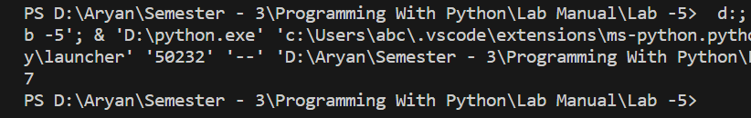

**Task 2:- Performing The Operation On Dictionary.**

**Python Code:**

dic1 = {'A' : 65,'B' : {'A' : 35 , 'B' : 54} ,'C' : 67}

print(dic1['A'])

print(dic1['B']['B'])

fruit = {'Apple':20,'Mango' : 23}

fruit1 = {'Grpares' :25 , 'Banana' : 35}

mix = fruit.update(fruit1)

print(fruit)

fruit.pop('Banana')

print(fruit)

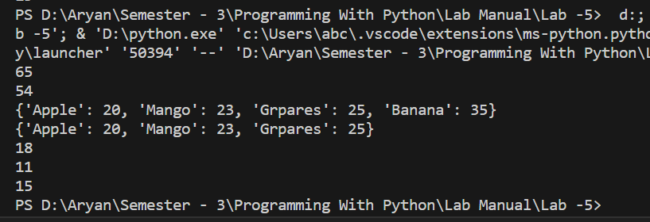**Output:**

**Task 3:- Performing The Operation On Sets.**

**Python Code:**

set1 = {1,1,3,"4",5,6}

print(set1)

s1 = {1,2,3,4,5,6}

s2 = {1,2,4,6,7,9}

print(s1.union(s2))

print(s1.intersection(s2))

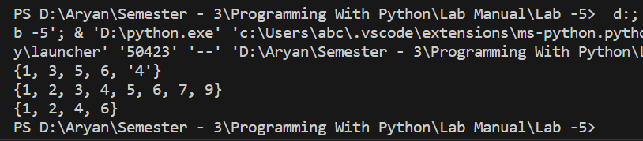**Output:**

**Task 4:- Implementing Different Types of Number System.**

**Python Code:**

print(0x12)

print(0o13)

print(0b1111)

**Output:**

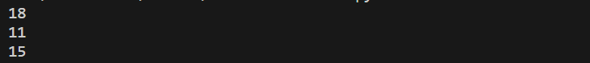

**Task 5:- Arithmetic Operators**

**Python Code:**

X = 5

Y = 2

print(X + Y)

print(X - Y)

print(X*Y)

print(X / Y)

print(X//Y)

print(X%Y)

print(X**Y)

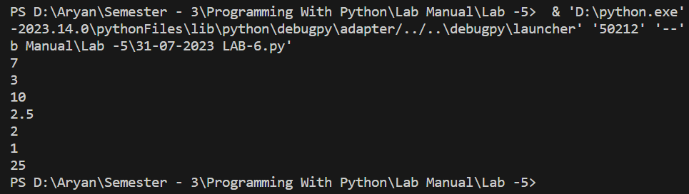**Output:**

**Task 6:- Logical Operators**

**Python Code:**

X = 56

Y = 43

print(X > 50 and Y < 50)

print(X > 50 or Y > 50)

print(not(X < 50))

**Output**

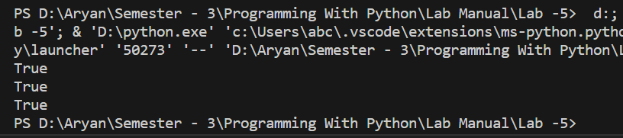

**Task 7:- Identity Operator**

**Python Code:**

A = [1,2,3]

B = [1,2,3]

C = A

print(A is B)

print(A is C)

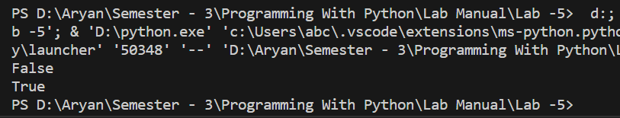**Output:**

**Task 8:- Member Operator**

**Python Code:**

A = 2

B = [1,2,3]

print(A in B)

print(A not in B)

**Output:**

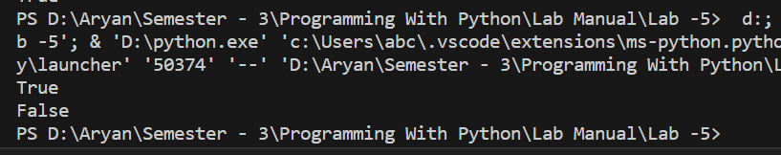

**Task 9:- Conditional Statement**

**Python Code:**

A = 3

if A < 3 :

print(f'{A} Is Greater Than 5')

else :

print(f'{A} Is Less Than 5')

B = 15

if B > 10 :

print("%d Is Greater Than 10" % B)

elif B > 5 :

print("%d Is Greater Than 5" % B)

else :

print("%d Is Not Greater Than 5"% B)

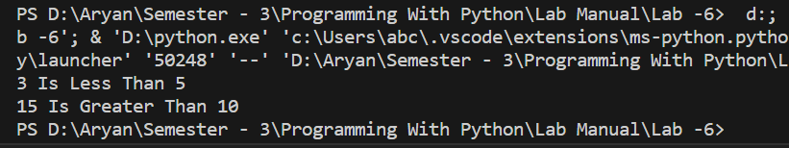**Output:**

**Post Lab**

**Task 1**

**Python Code:**

tup3 = ("A" , "R", "Y","A","N")

print(''.join(tup3))

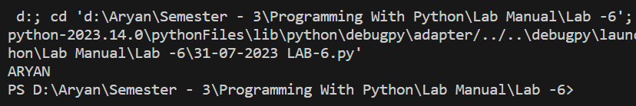**Output:**

**Task 2**

**Python Code:**

tuple1 = (11,22)

tuple2 = (99,88)

tuple3 = tuple1

tuple1 = tuple2

tuple2 = tuple3

print(tuple1)

print(tuple2)

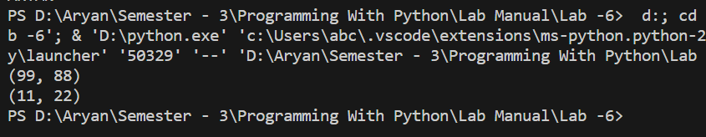**Output:**

**Task 3**

**Python Code:**

tuple3 = ("Orange" , [10,20,30],(5,15,25))

print(tuple3[1][1])

**Output:**

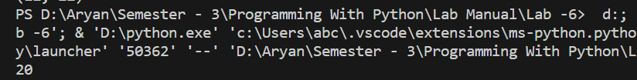

**Task 4**

**Python Code:**

tuple4 = (11,[22,33],44,55)

tuple4[1][0] = 222

print(tuple4)

**Output:**

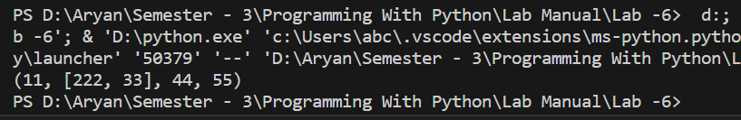

**Task 5**

**Python Code:**

for i in range(1, 11):

print(10, " ", i, " ", i * 10)

**Output:**

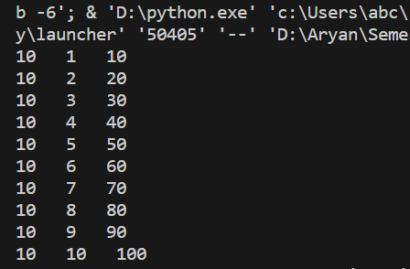

**Task 6**

**Python Code:**

for i in range(1,6):

for j in range(1 , 5-i) :

print(" ",end="")

for j in range(1,i) :

print(" * ",end="")

print("\n")

**Output:**

